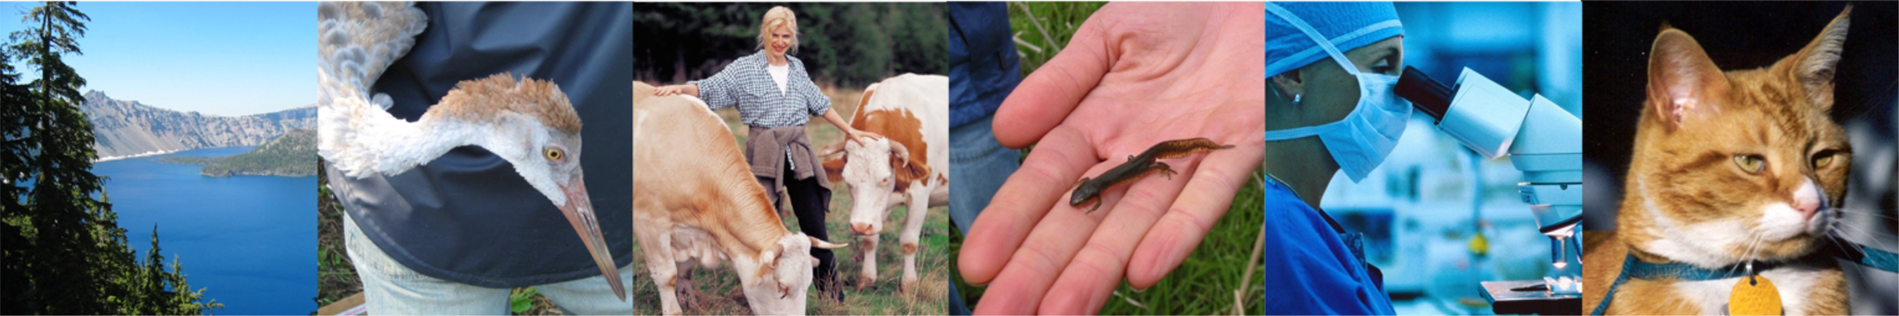
ONE WORLD, ONE MEDICINE, ONE HEALTH
One Health Intellectual Exchange
Fall Monthly Discussions: Philosophy to Practical Integration of
Human, Animal and Environmental Health

A fall monthly discussion series, sponsored by the North Carolina One Health Collaborative (NC OHC) within the NCBC Intellectual Exchange Group (IEG) Program to enhance collaborations between physicians, veterinarians, researchers and other local / global / environmental health professionals by increasing public awareness of the interconnectedness of people, animals and the environment.

Fall 2014 - Tuesday, September 23rd
5:30 – 7:30 p.m.

Three Goals, Two Species, One Medicine

William C. Eward, DVM, MD
Assistant Professor of Orthopaedic Surgery
Oncology Section, Duke Cancer Institute
Duke University

Meets Tuesdays, 5:30 – 7:30 p.m. at the North Carolina Biotechnology Center
15 T.W. Alexander Drive Research Triangle Park, NC 27709 Directions: www.ncbiotech.org/directions

For information on the spring, weekly One Health course options or to offer suggestions / ideas for the discussion series, contact NC OHC: nconehealth@gmail.com

For Speaker Cancellation notices and additional background on One Health and the NC OHC:
http://nconehealthcollaborative.weebly.com/index.htm http://onehealtheducation.blogspot.com/

Facebook: search ‘North Carolina One Health Collaborative’; Twitter: @NC_OneHealth

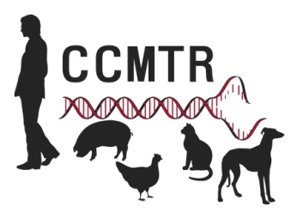
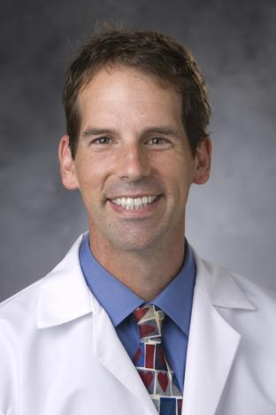

Will Eward, DVM, MD

After completing undergraduate studies at Duke University, Dr. Eward graduated from the Auburn University College of Veterinary Medicine in 2000, fulfilling a lifelong dream. In keeping with his plans to study comparative, interspecies medicine, he then completed an MD degree at the University of Vermont in 2006. With thoughts of One Medicine in the forefront of his mind, he decided on a career in orthopaedic oncology. An orthopaedic surgery residency at Duke and a surgical oncology fellowship at the University of Toronto completed the formal training. He currently spends his time as a surgical oncologist at Duke University (people) and the Veterinary Specialty Hospital of the Carolinas (small animals)

