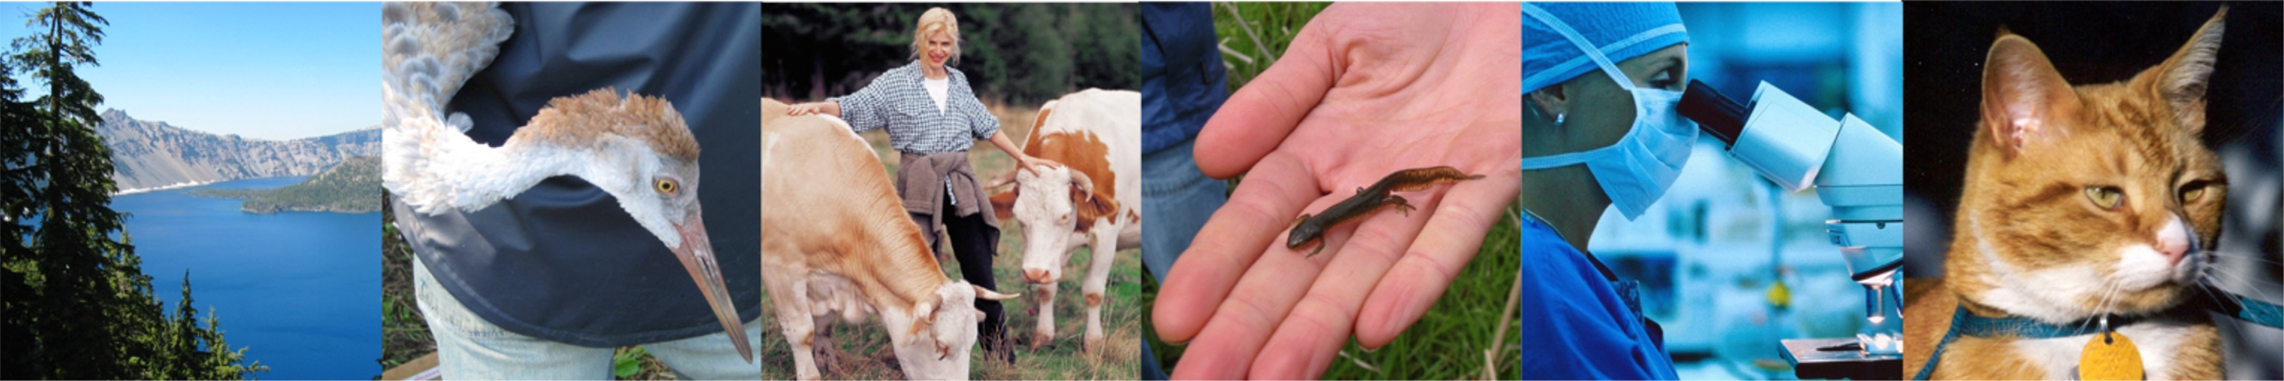
ONE WORLD, ONE MEDICINE, ONE HEALTH
One Health Intellectual Exchange
Fall Monthly Discussions: Philosophy to Practical Integration of
Human, Animal and Environmental Health

A fall monthly discussion series, sponsored by the North Carolina One Health Collaborative (NC OHC) within the NCBC Intellectual Exchange Group (IEG) Program to enhance collaborations between physicians, veterinarians, researchers and other local / global / environmental health professionals by increasing public awareness of the interconnectedness of people, animals, plants and the environment.

Tuesday, November 10, 2015 – co-sponsored with TriCEM
5:30 – 7:30 p.m.
Scary Viruses, Killer Tapeworms, and Nostril Ticks:
Unanticipated Adventures in One Health
Tony L. Goldberg, PhD, DVM, MS
John D. MacArthur Chair
Professor of Epidemiology, Department of Pathobiological Sciences,
School of Veterinary Medicine and Associate Director for Research,
UW-Madison Global Health Institute

Meets 5:30 – 7:30 p.m. at the North Carolina Biotechnology Center
15 T.W. Alexander Drive Research Triangle Park, NC 27709 Directions: www.ncbiotech.org/directions

For information on the spring, weekly One Health course options or to offer suggestions / ideas for the discussion series, contact NC OHC: nconehealth@gmail.com

For Speaker Cancellation notices and additional background on One Health and the NC OHC:
http://nconehealthcollaborative.weebly.com/index.htm http://onehealtheducation.blogspot.com/

Facebook: search ‘North Carolina One Health Collaborative’; Twitter: @NC_OneHealth

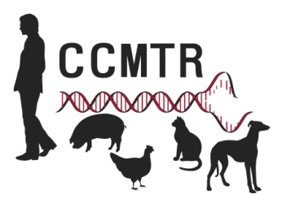

Speaker Bio:
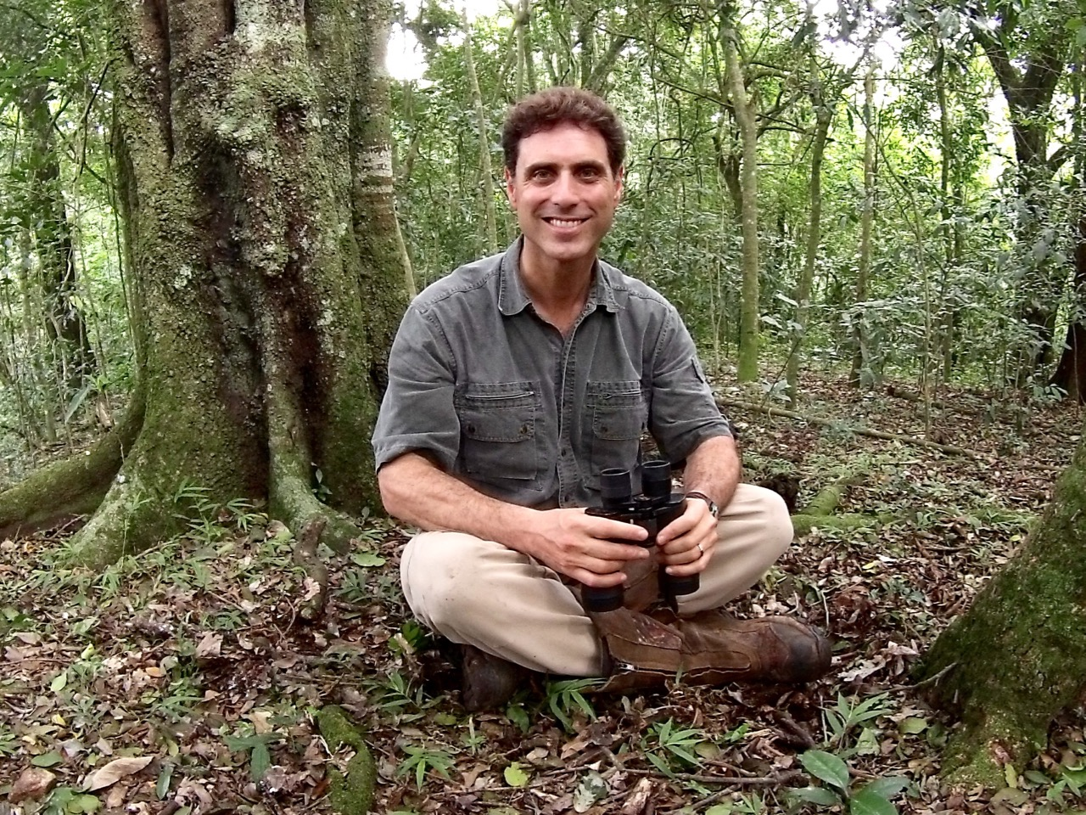 Tony L. Goldberg, PhD, DVM, MS.
My activities focus on the ecology, epidemiology and evolution of infectious disease. My research combines field and laboratory studies to understand how disease-causing agents are transmitted among hosts, across complex landscapes, and over time. I use tools ranging from field observation to molecular analyses to infer the transmission of disease-causing agents, from viruses to bacteria to protozoa and fungi. I combine this information with methods from the social sciences to understand the root drivers of disease emergence in “real world” settings. My overall goal is to discover mechanisms for pathogen transmission, emergence, and evolution that can be generalized across systems.
I am currently involved in a variety of projects around the world. In 2004, I founded the Kibale EcoHealth Project, a long-term study of health and disease in the people, primates and domestic animals of western Uganda (http://svmweb.vetmed.wisc.edu/KibaleEcoHealth/). This project uses a holistic, ecosystem-level approach to understand how changing land use patterns affect the transmission of diseases within and between species in Kibale National Park, a montane forest of exceptional biodiversity. The project also incorporates methods from the social sciences to understand how knowledge, beliefs and behaviors of local people contribute to cross-species pathogen transmission risk. Since 2008, I have led a long-term study of the ecology of West Nile virus in Chicago, Illinois. This project examines the “fine scale” features of the urban landscape in the west Chicago suburbs to understand why this area is a West Nile virus “hotspot,” (http://www.vetmed.wisc.edu/WNV/). My other projects focus on viral hemorrhagic septicemia virus in fish, white-nose syndrome in bats, , chytrid fungis in amphibians, and porcine reproductive and respiratory syndrome virus.
Most of my projects are place-based, focusing on well-defined ecosystems at fine spatial and temporal scales. My work therefore follows in the classical epidemiological tradition, in that it is grounded in the fundamentals of field observation and outbreak investigation. Nevertheless, my work also requires the development and application of novel methods. Currently, I am involved in efforts to adapt “next generation” DNA sequencing methods to discover and track new pathogens, I am developing novel computational tools for highly diverse pathogens to maximize the effectiveness of polyvalent vaccines, and I am exploring new methods for combining molecular information on disease-causing organisms with data on the behavior and ecology of their hosts, linking both to data on human behavior and social relationships.
The overarching goal of my work is to improve the health and wellbeing of animals and people while helping to conserve the rapidly changing ecosystems we share. My research is thus highly collaborative and cross-disciplinary. The magnitude of the health-related problems that the world faces today necessitates such an approach.

